InveStig8: The Zombie Apocalypse guide to referencing and sources

To write successful coursework and longer academic essays you will need to produce work that has other people’s ideas in it. To avoid plagiarism (You have information on what this means in the Getting to grips with academic honesty section of the website) you need to be able to successfully reference the sources you use in your research.

Every time you research something that you think you might be of interest to add to your article, you should make a note of it. There are different ways to do this and you should experiment to see what works best for you. We have provided a document (My InveStig8 References) which may give you a quick idea of how to organize this information. You can make your own copy of this document and start collecting information as you go through your project. There are also good online sources that can help you organize your references. A link to an example has been put on the website.

There are a number of different methods you can use for mentioning your sources. In this project we are going to try to keep things simple to get you used to the idea of using sources. Everything below highlighted in red is an example of how something may look/read/sound in your article.

Citations
If you are quoting someone else’s ideas or information from a source directly into your work, you need to add a citation. This just tells us that you are acknowledging where this information came from. All you need to do here is enter the authors name and the date the article or book was published. If you are accessing the information on a website you should add in the url and the date you accessed it.

Here is an example. Mr Greaves’ favourite book is the ‘Zombie Survival Guide’ by Max Brooks, it was published in 2003. If he was writing an article about surviving the Zombie apocalypse and wanted to use some information or ideas from the book, he could do it like this;

Some theories suggest that trees can be used as sniper platforms or to increase your ability to spot zombies from long distance (Brooks, 2003), however my own opinion is that climbing a tree can compromise your escape options and make you more visible to zombie hordes.

You can also quote directly from a text by writing the name of the person you are quoting and the date of the publication. For example;

Brooks (2003) states “Hand-to-hand combat should always be avoided. Given a zombie’s lack of speed, it is much easier to run (or walk quickly) than stand and fight” thus reinforcing the widely held belief that most zombies are lumbering, clumsy and slow.

Referencing
For every citation you use, you must also give the full details of the source in your reference list or bibliography. These follow a set format and the reference list document is designed to help you collect the information you need. Since Mr Greaves has cited his favourite book in his article, he must now create a Bibliography that will go at the back of his article. For a book you would have to add the authors name, the date the book was published, the title of the book, the city the book was published in (or where the publishing company is based), and the name of the publishing company. The reference for this book would look like this;

Bibliography
Brooks, Max. (2003). The Zombie Survival Guide. New York: Three Rivers Press
If your sources are not from books they might need to be added slightly differently. Below are some examples.

Articles from news websites, magazines or online databases. These can be cited the same way as books because they should have an author and a date. As a reference you should add the name of the article, the name of the newspaper and/or website and the date it appeared.

Citation example
The fact that many countries or areas of the world have already begun preparations for the upcoming zombie apocalypse (McGreal, 2011) can be taken as evidence that doomsday will soon be upon us.

This would appear as a reference as follows

Bibliography
McGreal, Chris. (2011). US Officials prepare for ‘zombie apocalypse’. www.guardian.com, Thursday 19 May 2011

You should also add citations and references for other sources of information that you find, for example video’s and documentaries from online sources or DVD’s can be used and recorded in the same way.

We would encourage you to include Pictures, charts, data, maps or any other images to enhance your article but make sure you also reference these in the same way.

If you are unsure about referencing, collect as much information as you can about the source and ask your teacher, or research yourself using the links in the Plagiarism & Referencing folder.
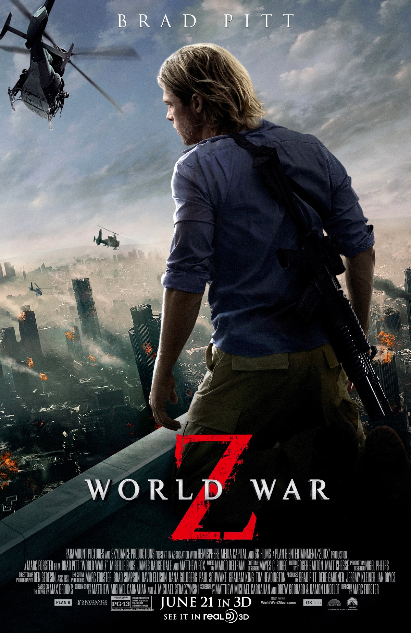

Image 1: The official World War Z movie release poster (BLT Communications, LLC (2013) World War Z. http://bltcommunications.com/)

