Picture | Description
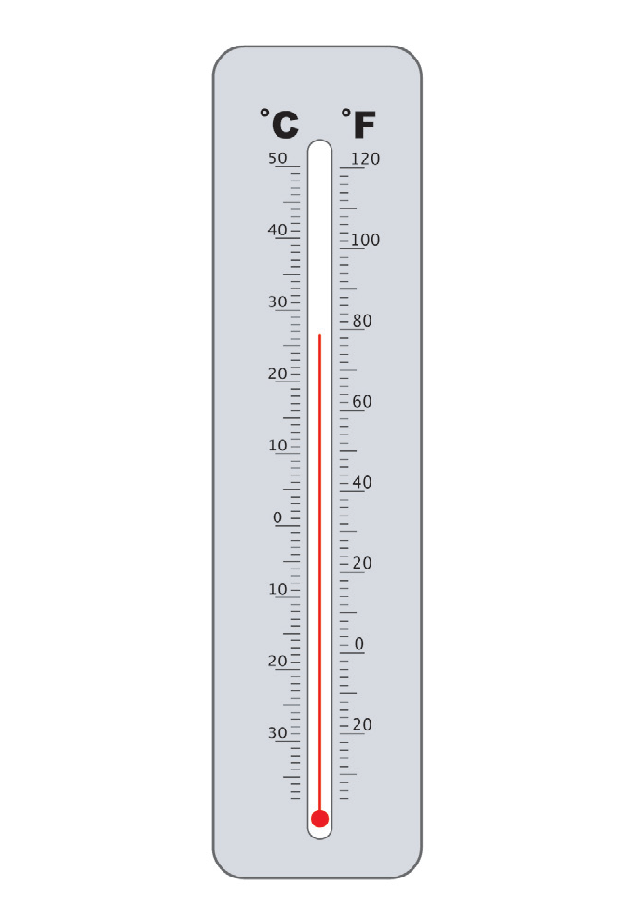 | - Measures solar radiation  - Placed on a flat surface to gain exposure to the full electromagnetic spectrum  - The more sunlight that strikes it, the more energy it produces
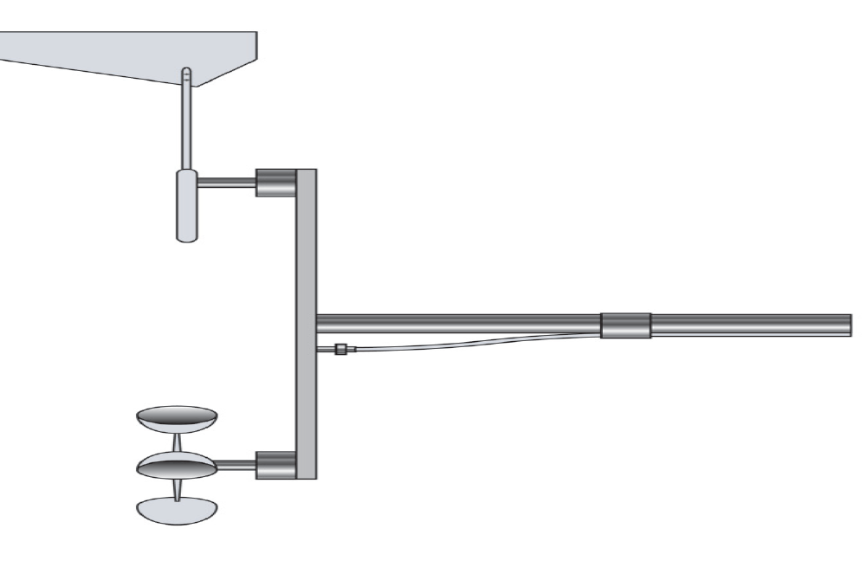 | - The measure of the distance something can be seen without distortion  - Measurements of less than 330 feet usually reported as zero  - Measurements usually reported in miles or meters
- Measure is subjective
- Can be very descriptive
- Not quantifiable
- Provides additional perspective
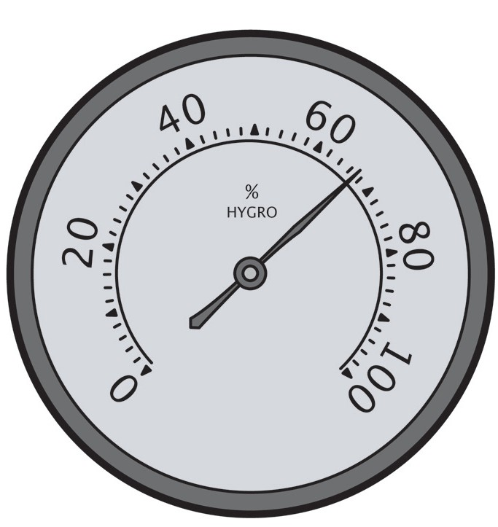 | - Used to photograph and track large-scale air movements  - May use infrared cameras to determine relative warmth of objects  - Can be polar orbiting or geo-stationary
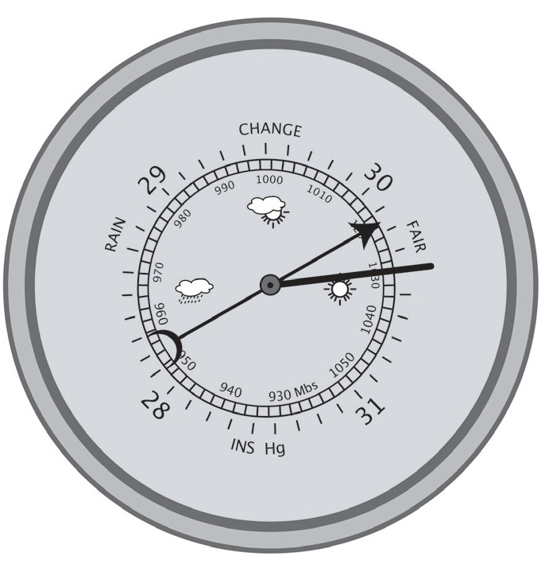  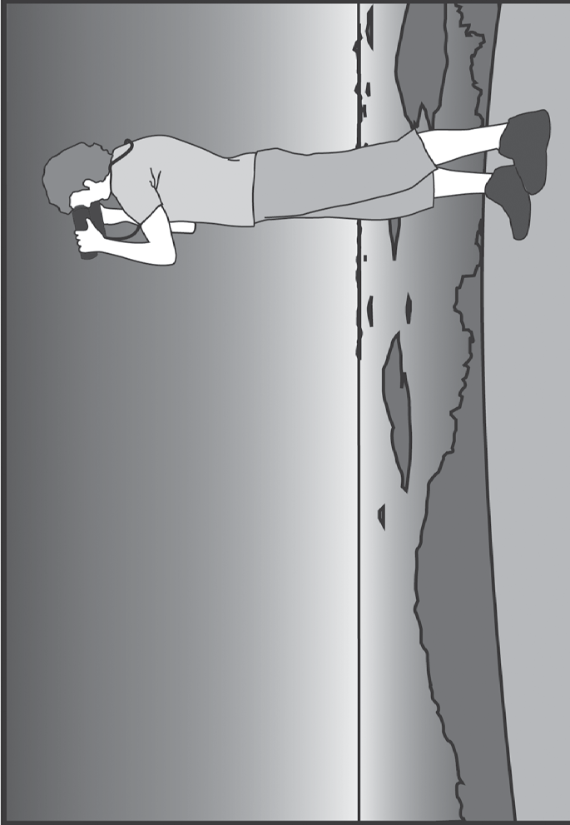 | - Determines direction from which wind is blowing  - Weight is evenly distributed on each side, but the surface area is unevenly divided with the pointer always on the side with the smaller surface area  - Not always reliable in small, gentle winds
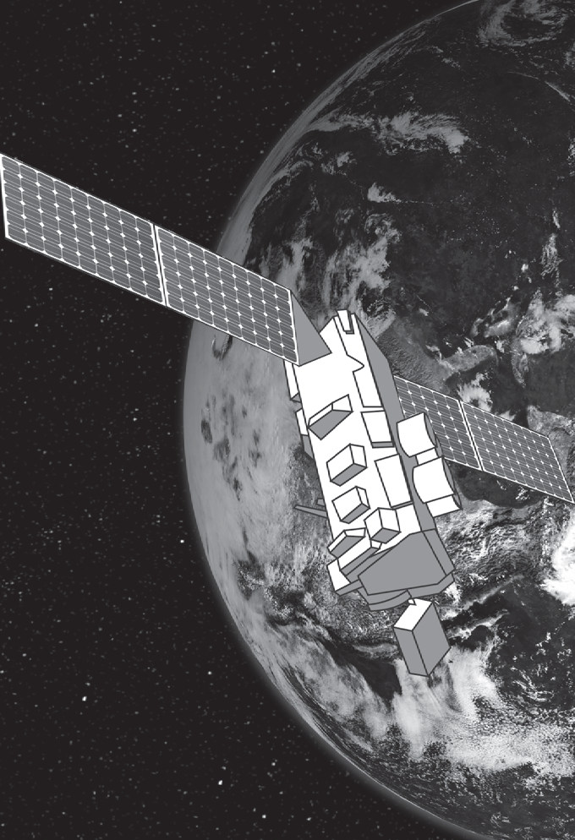 | - Measures relative humidity using the cooling effect of evaporation  - Made of two thermometers mounted together, one with a wet cloth wick over the bulb  - Differences in readings determine relative humidity—the greater the difference in readings, the less relative humidity
- Measures rain or snow over a set period of time
- Usually measured in millimeters but reported in inches
- Limitations include: collection during high wind events such as hurricanes can be unreliable; freezing temperatures can cause the funnel to freeze, preventing subsequent precipitation from collecting
- Variety of types
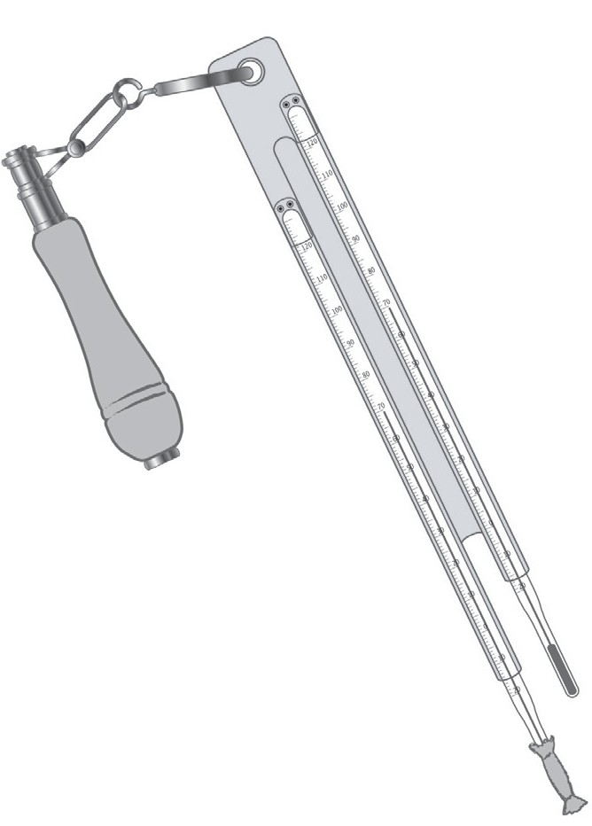  - Measures wind speed or velocity  - Measures the strength of air’s motion  - Measured 33 feet above ground level  - on buildings or airports  - Several cups catch the wind and spin  - around a pole  - Measured by the number of revolutions over a set period of time | - Measures humidity or amount of water vapor in the air  - Measures absolute (the amount of water vapor in a unit volume of air) or relative (the ratio of moisture in the atmosphere to the maximum moisture the atmosphere can hold) humidity  - Humans feel comfortable with a relative humidity between 30% and 60%
- Measures air pressure
- Weighs the amount of air in a specific place
- Usually measures between 28-31 inches of mercury
- A falling measurement usually means a storm is approaching
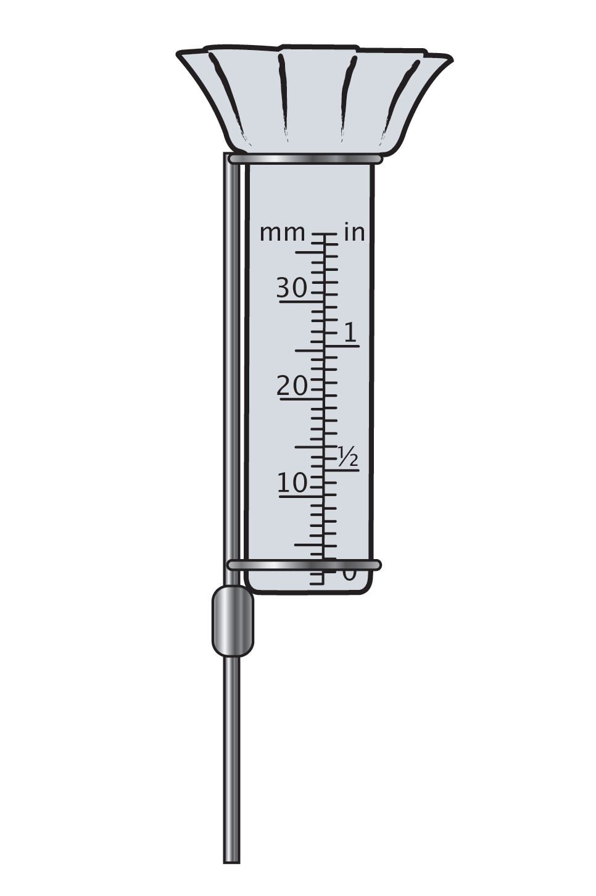 | - Measures heat content of air  - Measures in Celsius or Fahrenheit  - Measurement usually taken 5 feet above ground in a shelter  - Liquid expands or contracts causing it to move up and down a tube
