River Processes

In this section we will learn about the job performed by rivers to help shape the natural environment. These can be broken into 3 processes. Write a description of each process in the boxes below (you can use the pictures as a guide)

Erosion | Transportation | Deposition
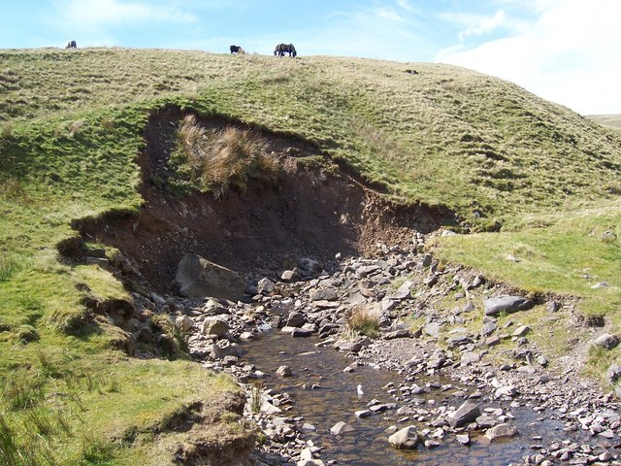 | 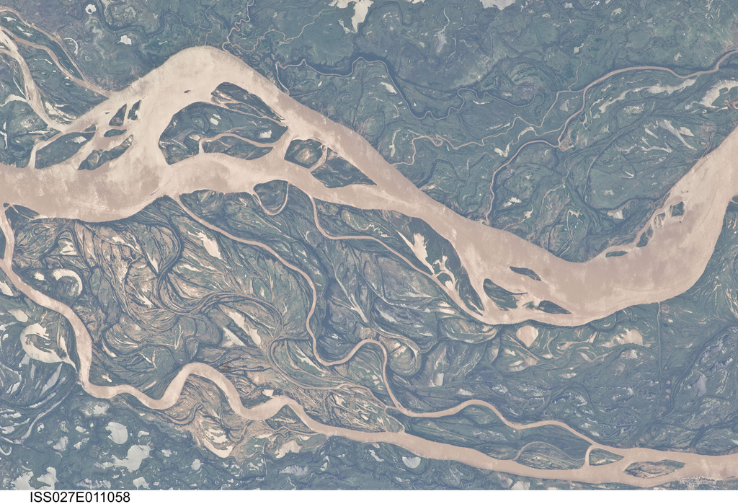 | 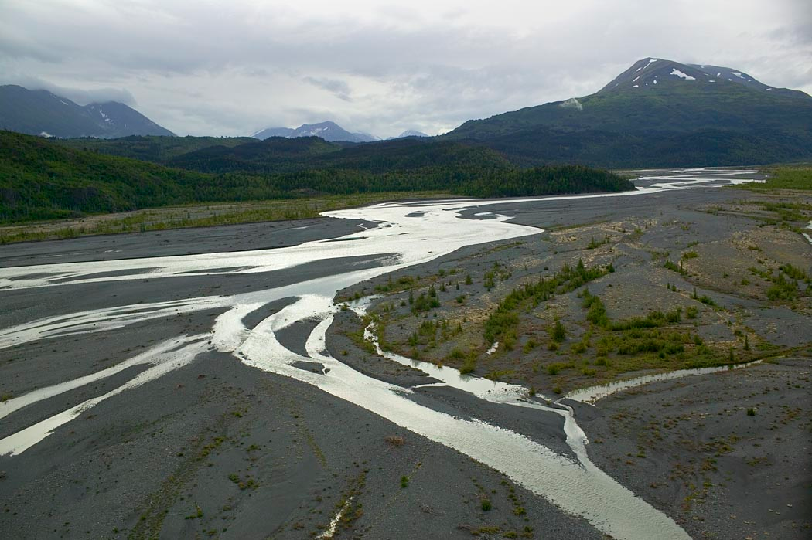

Now write explanations of the 4 ways in which erosion occurs

Attrition | Hydraulic Action
Abrasion | Solution

Transportation
Transportation is the movement of sediment or load along the course of a river. This takes energy. The more energy, the more load can be transported and the larger the individual particles can be.

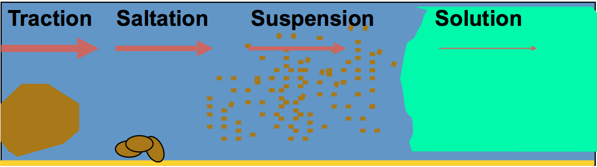

Using the diagram above, explain the relationship between the velocity of the flow in a river (shown by the red arrows) and the type of transportation that takes place.

Depostion

Q: Explain why deposition occurs by outlining different scenarios in a river system that would result in deposition occurring.

