Population pyramids

Population pyramids are very useful graphical representations of the population structure of a country or region. They help us to;

- See the age and gender structure of a country
- Understand population trends
- Identify the level of development of a country

To find out more, read pages 17-19 in your text books and then work through the questionson this sheet. Type your answers below each question (use a different font colour)

Question 1 – Population Structure and development

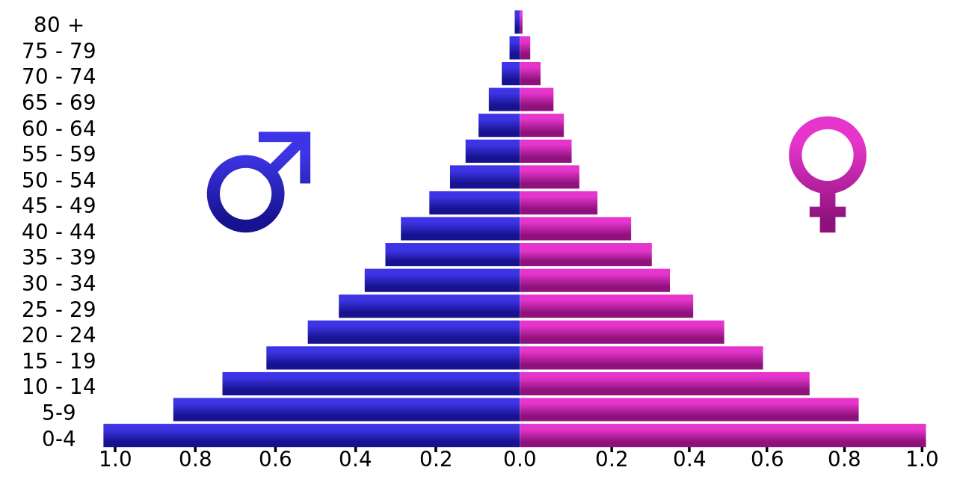
- Do you think this population pyramid represents the population structure of a highly developed country or a Less developed country?

- State the characteristics of the pyramid that drew you to this conclusion

- How do you think this population pyramid might change over time if the country develops?

- Can you guess which country this is (or which continent it is in)? give reasons for your guess

Question 2 – The demographic transition model
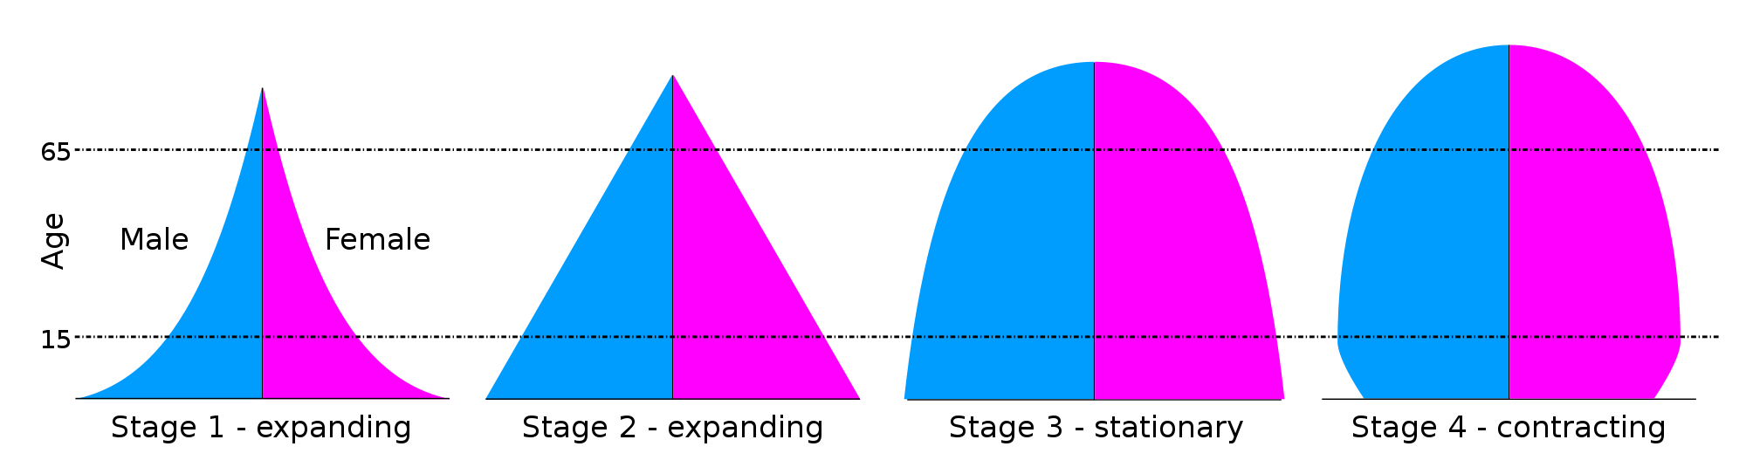

- Here are some examples of population pyramids related to the demographic transition model. For each pyramid, explain how the shape of the pyramid reflects the trends expected at each stage of the model

Stage 1

Stage 2

Stage 3

Stage 4

Question 3 – Assessing levels of development

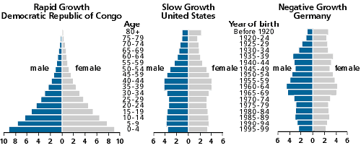

- What percentage of the population of the Democratic Republic of Congo is aged under 10 years old?

- What percentage of the population in the USA is female over 80?

- What 2 factors could cause the bulge in the population pyramid of Germany for the 30-39 age groups?

Question 4 – Change over time

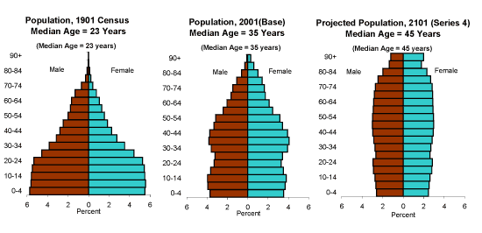
These population pyramids are all for the same country over a period of 200 years. The first two are based on real data, the final pyramid is a projection.

- Describe how this country’s population changed over time from 1901 to 2001?

- What social and economical factors might create the changes in the population structure between
2001 and 2101?

Question 5 – Country comparisons

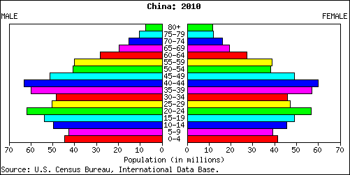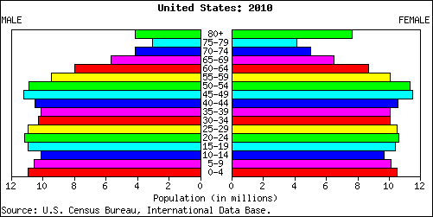

These population pyramids show the population for USA and China in 2010.

- Compare the two population pyramids highlighting the differences bewteen each country’s population structure

- Which country os more developed? Give reasons for your answer using the data shown by the population pyramids.

Question 6 – Comparisons between different regions in the same country

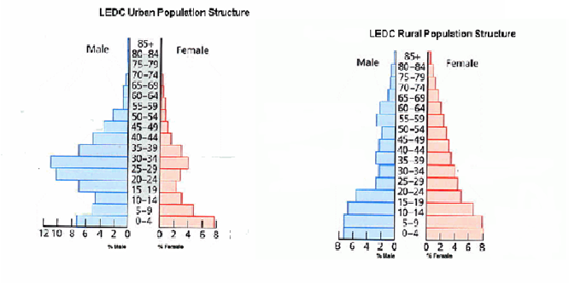
WARNING!!!! THIS IS A HARD QUESTION!!!!!!!!!!!!

- The population pyramids above show the population in a Less Economically Developed Country (LEDC) for both urban populations (people living in cities) and rural populations (people living in the countryside). Can you give reasons why you think there is a higher proportion of males living in urban areas?

- What social and economic impacts might such a population structure have in either the rural or the urban areas of the country? Pick either the rural or urban area and fill in the following table.

Positive Social Impacts | Positive Economic Impacts
Negative Social Impacts | Negative Economic Impacts

Question 7 – Exam practice question

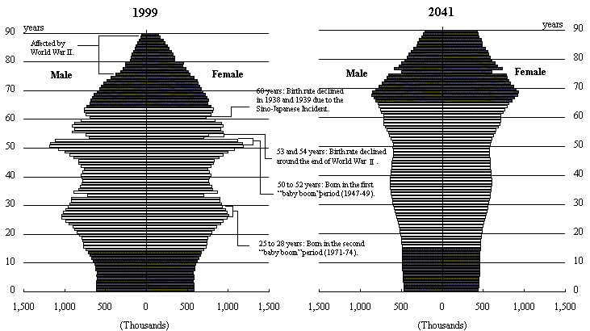

The above population pyramids show a historical and future projection for the population of Japan. With reference to the population change shown between 1999 and 2041, what considerations will need to be made in the provision of services and employment within this time range? (6)

Question 8 – Population Projections and Momentum

- Define the following terms

Population Projection

Population Momentum

- Why is population momentum more applicable to developing nations than more developed countries?

- What is the point of population projections?

Additional activity

- The following website shows you how to construct a population pyramid in excel. This could be really useful (or you may never use it again) either way, have a practice!

www.excel-exercise.com/charts/population-pyramid

