Student name:
Group Members:

MYP Y6 Individuals and Societies
Unit 3-Food Fight?
End of Unit Assessment: Project Development Booklet

Part 1 Project Information (Criterion A: Knowing and Understanding)

What is the name of your project?

What is your project about?

How will your project help with food sustainability?

What kind of positive impact does the project bring to the environment?

Who is your target participant?

How will you promote your project in an interesting and creative way?

Part 2 Planning (Criterion B: Investigating)
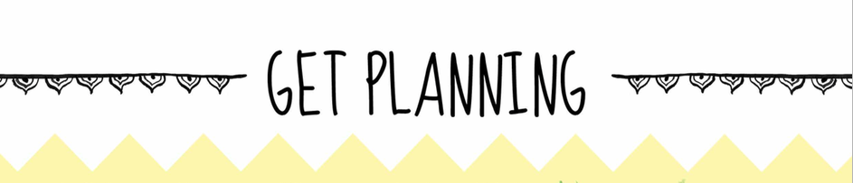

Timeline of my project:
Step  (What will happen in this step?) | When? | Where will the project take place?
e.g. Brainstorming project ideas with group mates | 3rd Nov-4th Nov | Classroom

What materials do you need?
Materials | Amount | Who will bring in this material?
e.g. A4 White Paper | 10pieces | Mandy Yan Yan

How does your group share workload?
Name | Job | When to bring in
e.g. Mon Mon | Printing out all promotion leaflets | 15th Nov

Part 3 Process Journals (Criterion B: Investigating)
The process journal should be used to record progress honestly, with your thoughts, ideas, decisions, feelings and reflections as you do your project.
You must record 5 pieces of journals as the project goes along. You should inculde some pictures as part of your entry.
This is what your teacher will use to determine your progress.

Journal 1 | Insert pictures here | Date:  What did I do?  Why did I do this?
Journal 2 | Insert pictures here | Date:  What did I do?  Why did I do this?
Journal 3 | Insert pictures here | Date:  What did I do?  Why did I do this?
Journal 4 | Insert pictures here | Date:  What did I do?  Why did I do this?
Journal 5 | Insert pictures here | Date:  What did I do?  Why did I do this?

Part 4 Reflections (Criterion B: Investigating)
About Yourself:
What is the most important thing you learned in this project?
What level of personal effort do you feel you put into your project?
What do you wish you had spent more time on or done differently?
What part of the project did you do your best work on?

About the Project:
To what extent do you think the project has succeeded (1 is extremely unsuccessful;5 is extremely successful) ?
Give a brief description of the result of your project.
What was the most enjoyable part of this project?
What was the least enjoyable part of this project?

