Population Distribution and Density

What is Population Distribution?

What is Population Density?

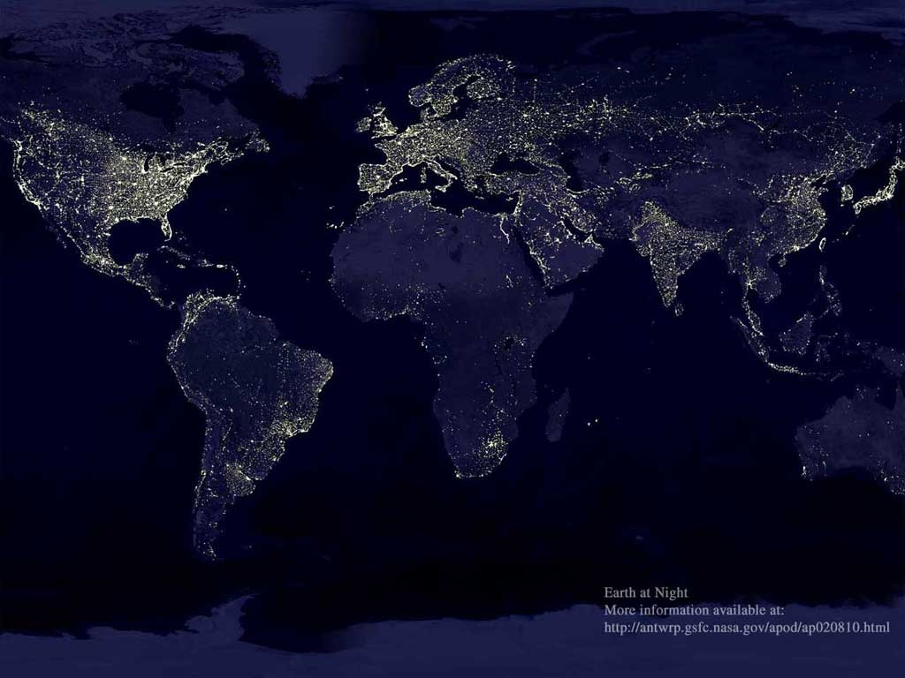
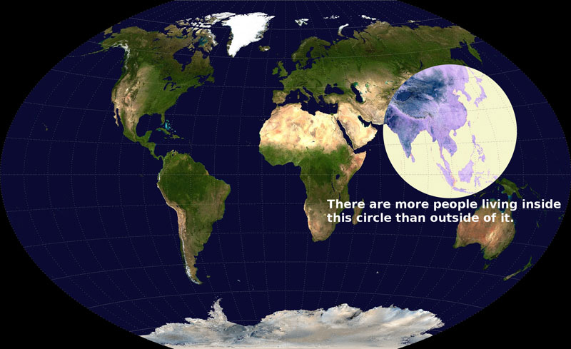

We’ve already seen the image on the left which shows ‘the earth at night’ it is sometimes used as an indicator of population density, but there is a big problem with this – what is that?

Does the image on the right give evidence for or against your answer to the previous question? (explain your answer)

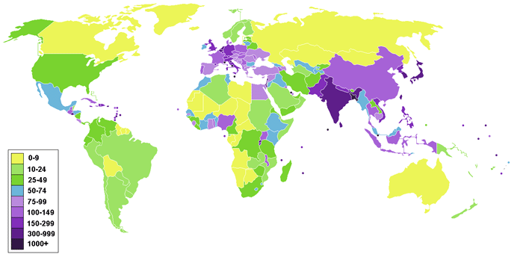
Using the map above, describe global population density.

What are the potential problems with this map?

List 5 things that you think have an impact on whether there is a high or low population density in any place. (i.e. Why would make a lot of people want to live somewhere? Or not many people live somewhere? Hong Kong has good examples of both!)

