Key facts
Restaurants Worldwide: Number of countries: Number of employees:
What is a franchise and how does it work?

How has franchising helped McDonalds to grow?

Key Facts
Proportion of American cows used for McDonalds: % of US potato crop used by McDonalds:

Extract the key facts regarding McDonalds growth from 1965 – present using information from the book and the map on p162 and outline them below

Suggest reasons why McDonalds is so popular in Taiwan? (look at the data on p162 as a starting point)

In relation to information about McDonalds revenue (p163) circle the 2 regions with the largest revenue generation and put rectangles around the 3 regions of fastest growth.
USA Europe Africa Middle East Asia-Pacific
Outline in bullet points the challenges McDonalds have faced in recent and some of its responses. Where possible, draw connecting lines between the challenge and the response to show how well McDonalds is adapting.
Challenges Responses

Where do you think future growth will come from for McDonalds? Explain your answer

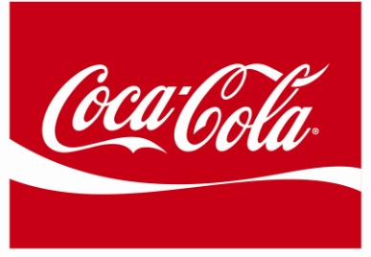

Name some soft drinks brands that are also owned by Coca Cola

Look at figure 6 p165. Compare the growth rates of Coca Cola in the USA, India and China.

Give reasons why growth is so dramatic in developing countries.

Describe how Coca Cola’s production has changed within the China market

Outline the social projects that Coke has been involved with in China and explain how this affects the Coca Cola brand image

Why do you think Coke sees urbanization in China as beneficial to increasing its market

How much did Coke invest in India in 1993 and how long did it take to turn this into profit?

