Practising exam style questions

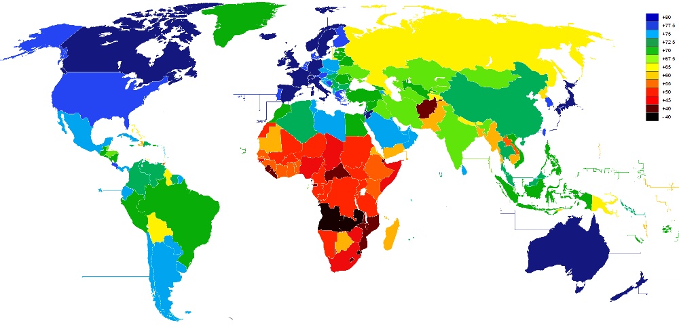
Describe the pattern of global life expectancy

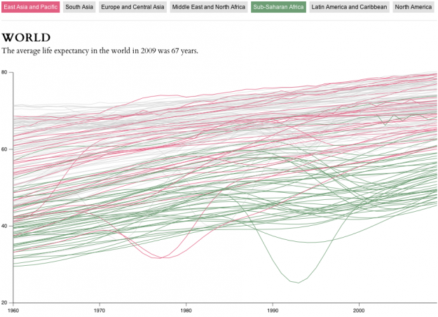

Describe what has happening to global life expectancy in the last 50 years?

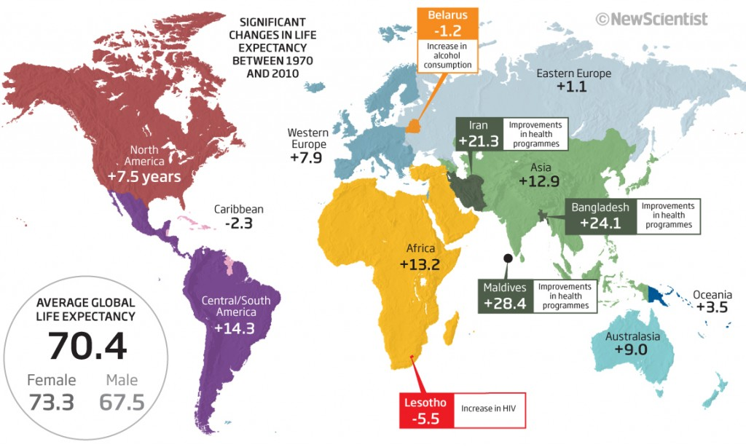

Compare the current trends in life expectancy by region/continent

Suggest reasons why life expectancy shows such a high variety across
countries in Asia. Use examples from the list above

