Part 1: Health
The Geography of Food and Health

The Geography of Food and Health is all about the way in which the availability of food and susceptibility to disease affects the health of a population. In the world these factors can change between countries and regions. Much like the Core unit Disparities in Wealth and Development, we will start of by looking at some key indicators.

Infant Mortality Rate (IMR)

1) Write a definition for IMR which includes the calculation

2) Study the map below which shows countries expanded or reduced in size depending on their IMR

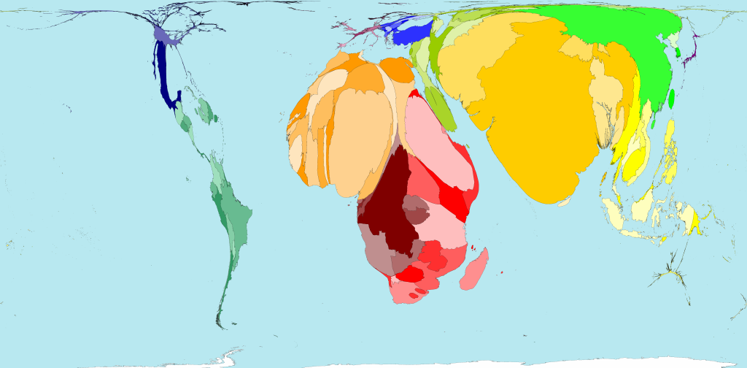

Describe the global situation with infant mortality rates, naming continents, regions or individual countries where appropriate.

3) Why is IMR a good indicator of health?

Life expectancy

1) Write a definition for Life expectancy

2) Study the map below, it shows life expectancy of different countries in years

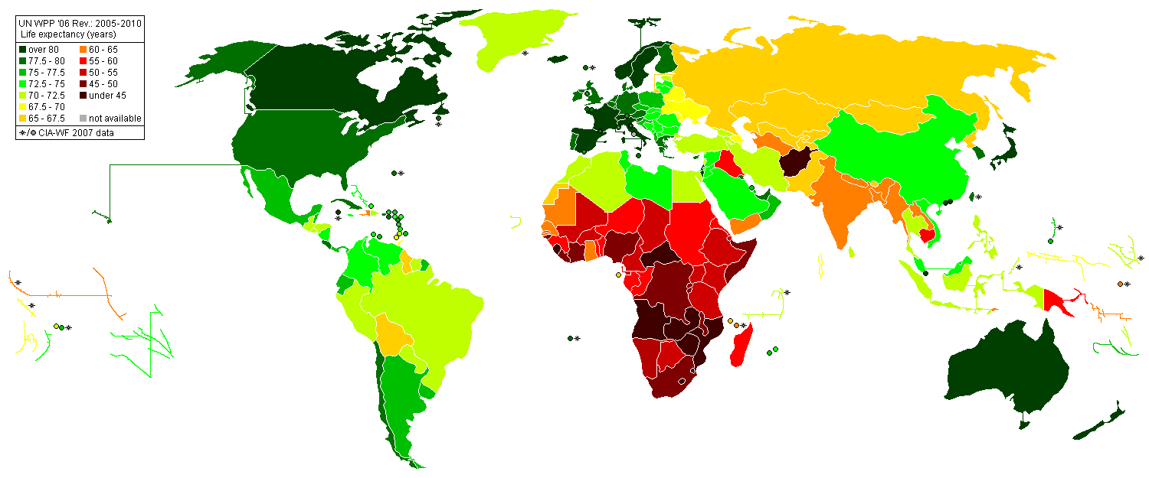
"Life Expectancy 2005-2010 UN WPP 2006" by Panagiotis V. Lazaridis https://commons.wikimedia.org/wiki/File:Life_Expectancy_2005-2010_UN_WPP_2006.PNG#/media/File:Life_Expectancy_2005-2010_UN_WPP_2006.PNG

Describe the global situation for life expectancy, refer to the map and add data where possible.

3) Why is Life Expectancy a good indicator of health?

Calorie Intake

1) Write a definition for calorie intake , include the WHO recommended calorie intake

2) Visit page http://chartsbin.com/view/1150 Analyse the map and the data table. Descibe the global situation of calorie intake by continent.

3) What makes calorie intake a good indicator of health?

Access to safe drinking water

1) What is meant by “safe drinking water”

2) Use the data from the map to rank the Continents in order of highest to lowest access to safe, clean drinking water.

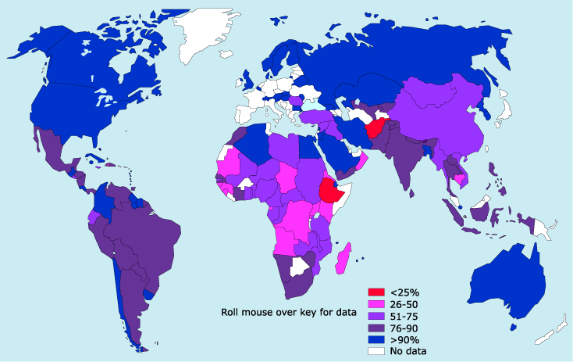

2) Why do you think Europe has a lot of countries with no data?

3) What issues are faced by those people who do not have access to safe drinking water?

4) Do you think this is a good indicator of health?

