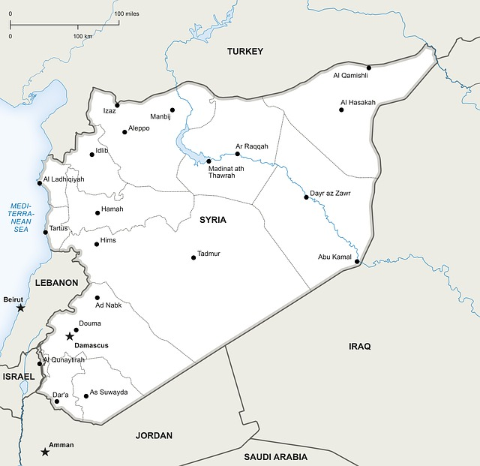
Forced Migration:
Syria

1) Which continent is Syria in?

2) Name the countries on the map that border Syria.

3) How would you describe the region where Syria is located

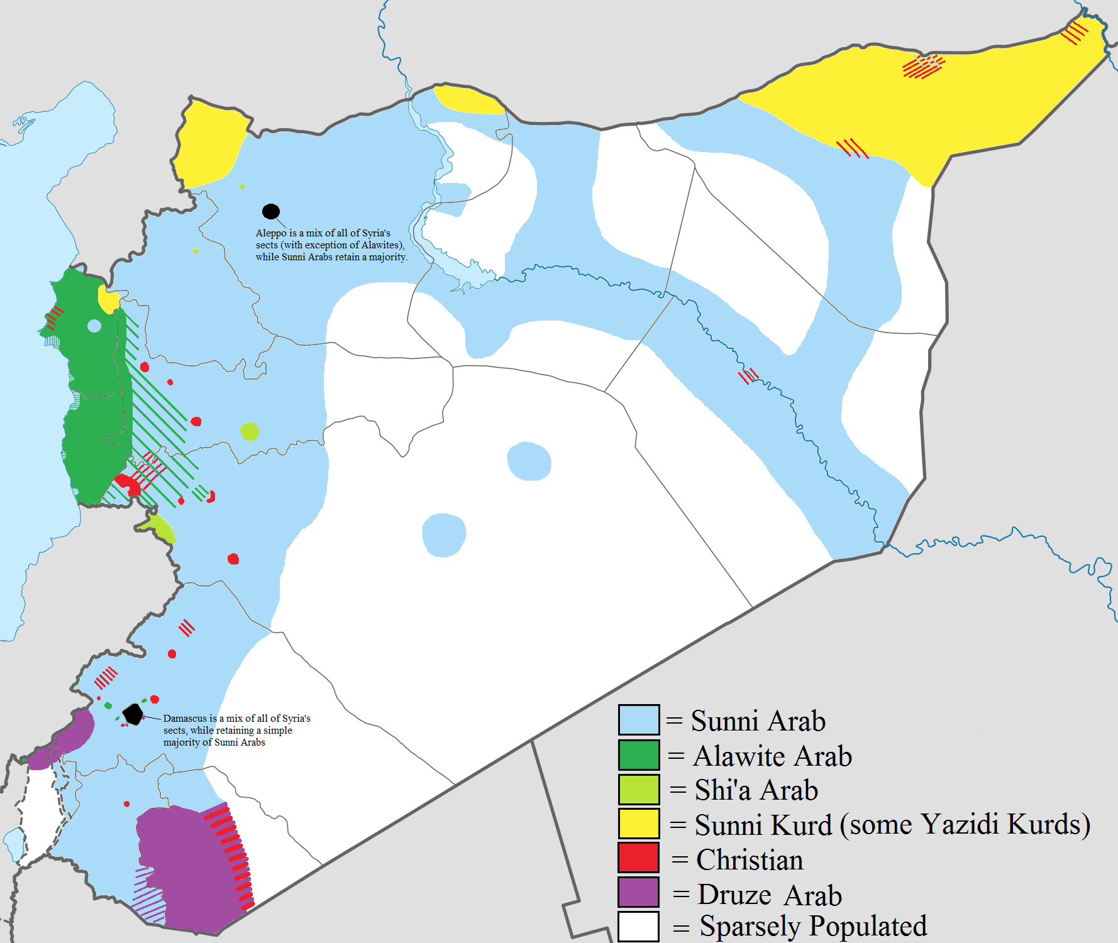
4) Look at the map on the left. Describe the distribution of religions in Syria

In this next section you will have to do some research to find out some key facts about Syria and the refugee crisis

5) What is the GDP per capita in Syria?

6) What were the main industries in Syria before the start of the civil war?

7) Can you find out who the major trading partners for Syria were before the civil war (who did they export their goods to?)

8) Read the article http://www.bbc.com/news/world-middle-east-26116868 which gives an overview of the conflict in Syria. Produce a bullet point summary of the article with points for the heading given. Remember to include key information (data, dates etc)

- Uprising turns violent

Descent into civil war

War crimes

Chemical weapons

Humanitarian crisis

Rebels and the rise of the jihadists

Peace efforts

Proxy war

9) People of your age are fighting in the war in Syria. How much would you like to be there? (give a reason)

10) How many people are now thought to have left Syria as refurgees?

11) Describe below some of the hardships that the refugees are currently living with.

12) What role do you think religion is playing in the conflict in Syria?

13) Where are the refugees going? Produce a table showing the top 10 countries that have taken in Syrian migrants and the number of people who have entered these countries.

 | Name of country | Number of migrants
1
2
3
4
5
6
7
8
9
10

14) What issues are the migrants facing once they have left Syria?

15) Describe the journey of a migrant who has left Syria and is trying to get to the UK. Which countries would they have to travel through and what problems would they face on the way. Aim to write a detailed account.

16) Name a country that has made it easy for Syrian refugees and describe what they have done.

17) Name a country that has made it hard for Syrian refugees and describe what it has done.

18) Some people think that refugees from Syria are not actually forced migrants. Instead, they think that they have voluntarily come to Europe to find themselves a better life. What do you think? Give reasons for your answer.

