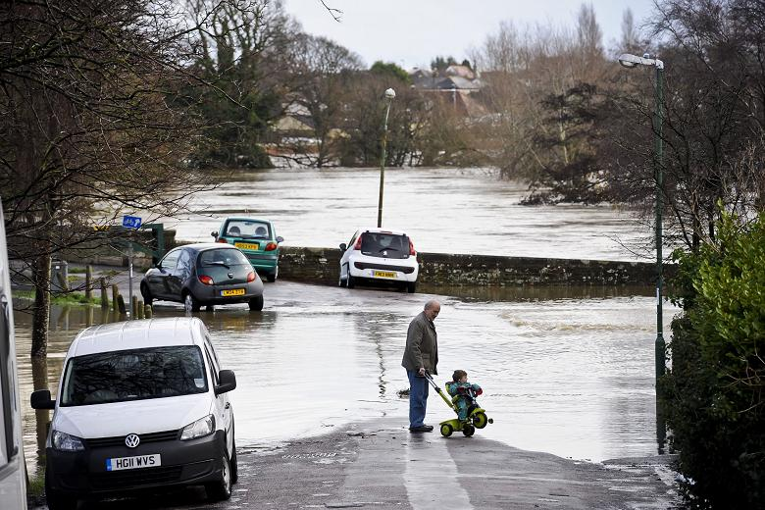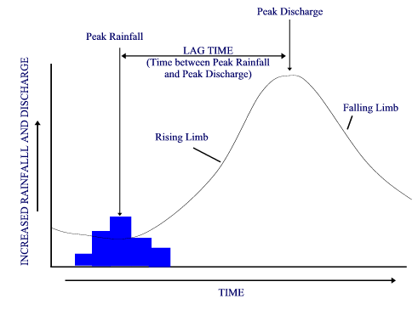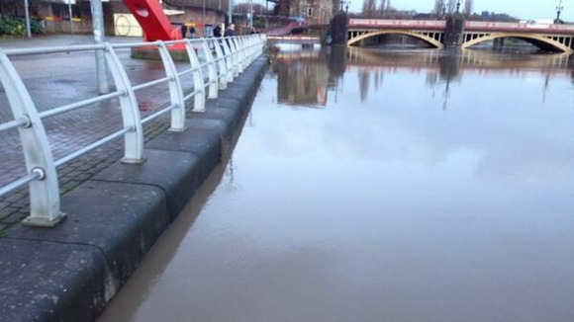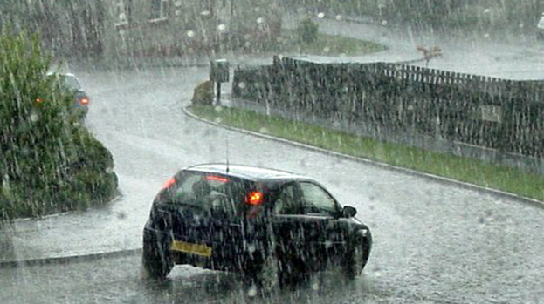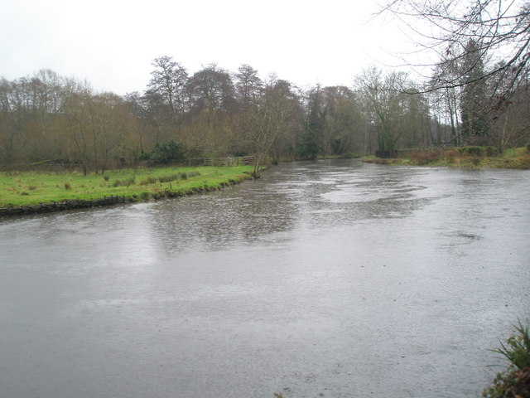**Flood hydrographs**

1.

1. Use these words to label the hydrograph:
2. Lag time
3. Peak rainfall
4. Peak discharge
5. Rising limb
6. Falling limb
7. What does the hydrograph show?
8. Match the pictures to the 4 different times: a) peak rainfall, b) rising limb, c) peak discharge, d) falling limb

431.

31.

21.