Fertility

Fertility can be measured in a number of different ways. Your first job is to look at the following measures and choose which you think is the best way to measure fertility. Research each to find out what they are

Crude Birth Rate General Fertility Rate Age Specific fertility Rate
(CBR) (GFR) (ASFR)

Total Fertility Rate Gross Reproduction Rate Net Reproduction Rate
(TFR) (GRR) (NRR)

Chose one which you are most comfortable with (that you think is a good measure of fertility).

1) Name your chosen measure?

2) Give reasons why you think this is the best measure for fertility

Look at the following website;

www.insidermonkey.com/blog/10-countries-with-the-highest-fertility-rates-348013

3) What measure of fertility rate is being used in this top 10 list?

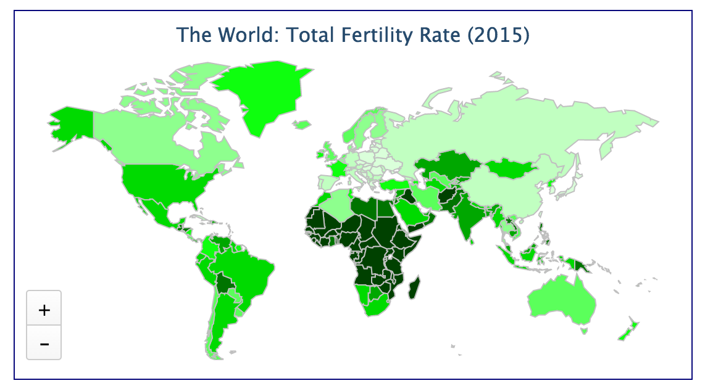
4) Now download the map of Africa from the website as a powerpoint. As you read through the top 10 countries on the website, highlight all of the countries mentioned in Africa on your map and add an anotation showing the fertility rate.

5) The map of total fertility rate shown above shows a very clear pattern for countries with high fertility rates. Describe this pattern.

6) Read the New York Times Article ‘Bye-Bye Baby’. www.nytimes.com/2014/04/05/opinion/sunday/bye-bye-baby.html?_r=0

Does the article suggets there is a spatial pattern for countries with low birth rates?

7) Now read the following articles. One is about Japan, a country with a very low birth rate, the other is about Niger, a country with a very high birth rate.

Niger: www.economist.com/news/middle-east-and-africa/21612239-runaway-birth-rates-are-disaster-population-explosion

Japan: www.bbc.com/news/world-asia-30653825

As you read each article, complete the table below to add in the negative aspects of each country’s population trend.

High Fertility Rate | Low Fertility Rate
Negative impacts example: Niger | Negative impacts example: Japan

8) CONGRATULATIONS!!!! You have just been made the head of state for one of these countries (president, prime-minister, emperor, queen, king, dictator – you can choose). Your first task is to address the population issues. Write out a plan showing the ways that you will tackle this. Come up with ideas that will a) Reverse or slow down the population problems in your country b) Reduce or remove some of the negative impacts of the current population situation.

