Ageing and Youthful Populations

1) Write a definition for Ageing Population.

2) Write a definition for Youthful Population.

3) Write 5 bullet points to show the issues Gambia faces with it’s youthful population.

4) Write a definition for dependency ratio.

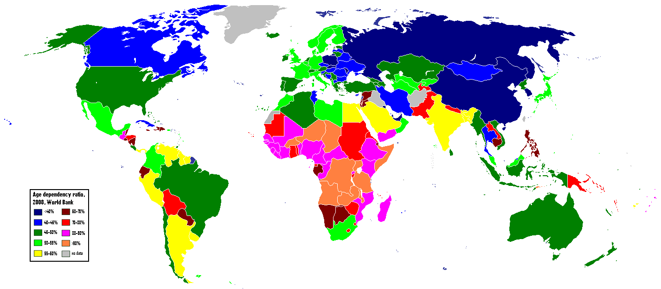

5) Describe the pattern for dependency ratio shown in the map above

6) Is it better to have a high or a low dependency ratio? (explain your answer)

