Now we're going to practice the skill we learnt earlier in the unit.

How to make a choropleth map. Use the following information about education levels in Hong Kong and income, create two choropleth maps and try to find a relationship between income and education.

Income disparity is often related to the education levels of each district, city, region or country. When comparing education, we can use Post Secondary / Tertiary Education (專上教育) as an indicator (指針) of education levels. Create a choropleth map of the percentage of people with Post Secondary education in each district.

Median income is the final map that you are going to create. Median income is the average income for each of the working age people living in a district, city, region or country. It is often related to the level of education that you hold and the industry that you work in. Below, you will see the data for the map you will create on median income.

Click below for the file to use for uploading to Sumopaint

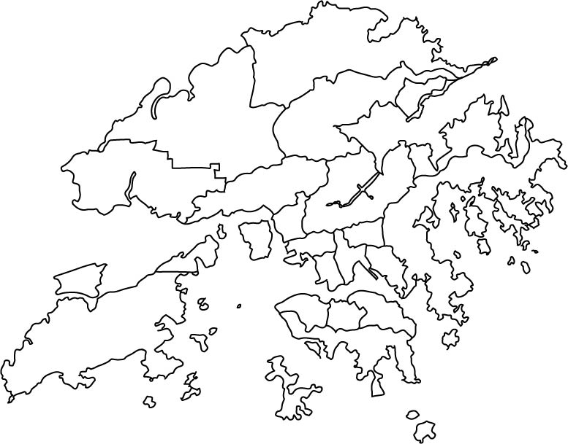

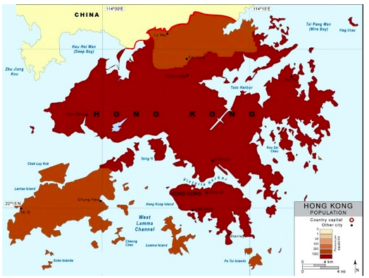
Use SUMOPAINT www.sumopaint.com/app/ to create a choropleth map.

Here is the information required to make the maps for both education and income.
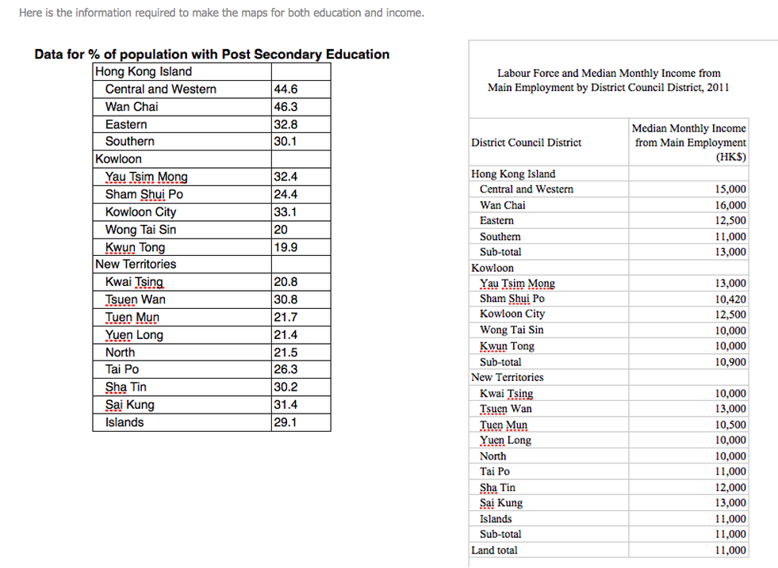
Describe the maps that you have just created using some of the terms below.
If you aren’t sure of the word, look it up.
Try to look for and describe general patterns to describe it. What does it look like? Is there a pattern?

- evenly distributed 均勻分佈
- unevenly distributed 分佈不均
- dispersed 疏散
- clustered 集群
- random 隨機
- regular 固定
- scattered 疏散
- concentrated 集中
- nucleated 核

Is there a relation between income and education?
ex. Do districts with higher monthly median income, have a higher % of tertiary education?
